Naloxone Workshop in Mechanicsville
Wednesday May 17th, 7 to 8pm
Laroche Community Center @ 51 Stonehurst Avenue
With: Mark Barnes, Respect Rx Pharmasave and the Canadian Pharmacists Association
**Pre-register with your OHIP card for a free kit available for pickup that evening
Contact: holly_cartwright@outlook.com
Childcare provided by Somerset West Community Health Center
Everyone welcome !!!

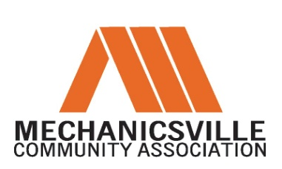

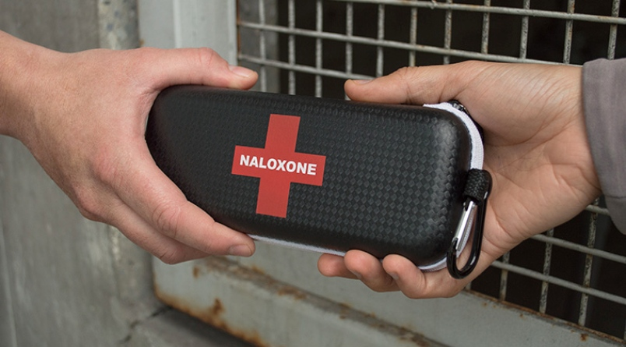

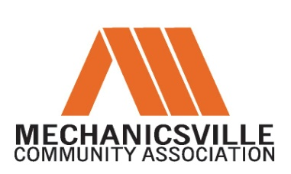
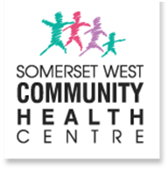

NALOXONE is an emergency medication that reverses the effects of an overdose from opiods (e.g. Heroin, Methadone, Fentanyl, Morphine).

