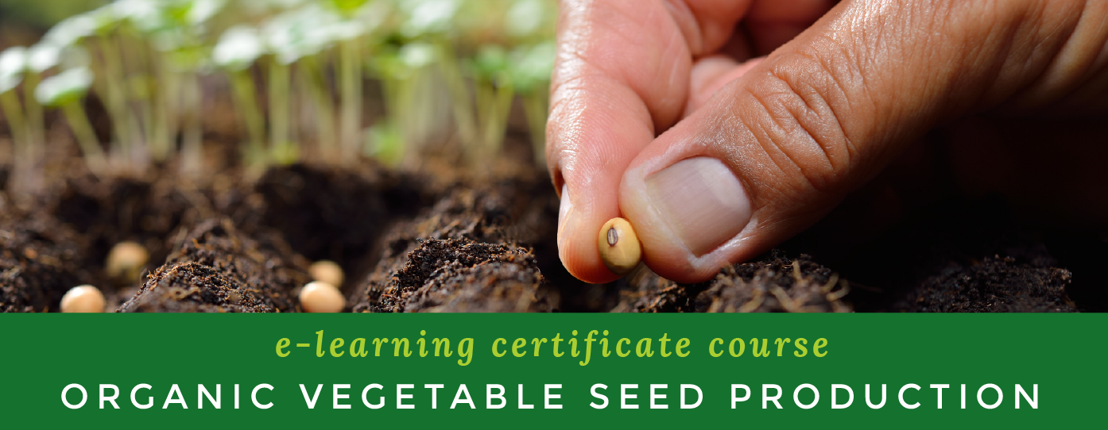

COG will host Canada’s first intermediate, online certificate program on

Canadian Organic Vegetable Seed Production in the Spring of 2017.

Want to learn more about producing organic seeds? Want to learn more about their commercial production, harvesting, quality, marketing, breeding and more? Want to build your own seed business following your own unique seed-farm business plan?
If so, this course is for you!
In partnership with USC Canada through The Bauta Family Initiative on Canadian Seed Security, COG is excited to open registration for Canada's first, intermediate-level Organic Vegetable Seed Production e-learning certificate!
This 22-week program begins April 10th, and will be delivered in a part-time blended format featuring live, online instruction with two expert instructors and successful organic seed producers, Mary Brittain of The Cottage Gardener and Patrick Steiner of Stellar Seeds. An optional 40-hour in-field experiential learning practicum is also offered at an additional cost. The practicum will partner students with seed mentors to give them hands-on experience of working on a seed farm.
The course will focus on building the competencies needed for successful commercial, organic seed producers. Modules covered in this certificate program include:

1. Organic Farming Practices
2. Organic Seed Production and Harvesting
3. Organic Seed Quality Assurance
4. The Business of Organic Seed Production
5. On-Farm Organic Plant Breeding
Early Bird Registration Fee: $1100 (goes up to $1250 on April 1st)
Practicum Add on: $400
Payment plans are available. Contact education@cog.ca for more information.
Students will be issued a tax-deductible tuition receipt.

For more details visit the course info page here or call us at 1-877-375-7383.
Register Today

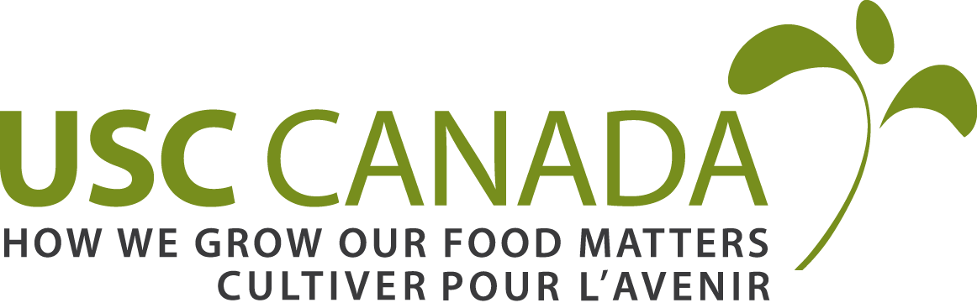 |  | 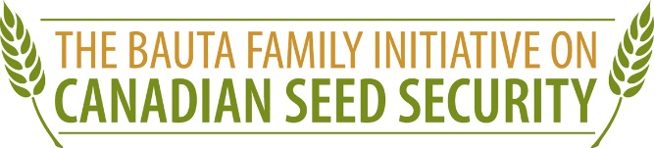

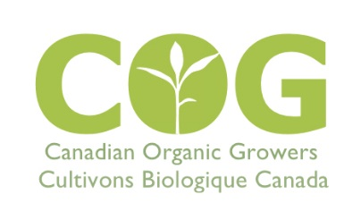

IMAGE:
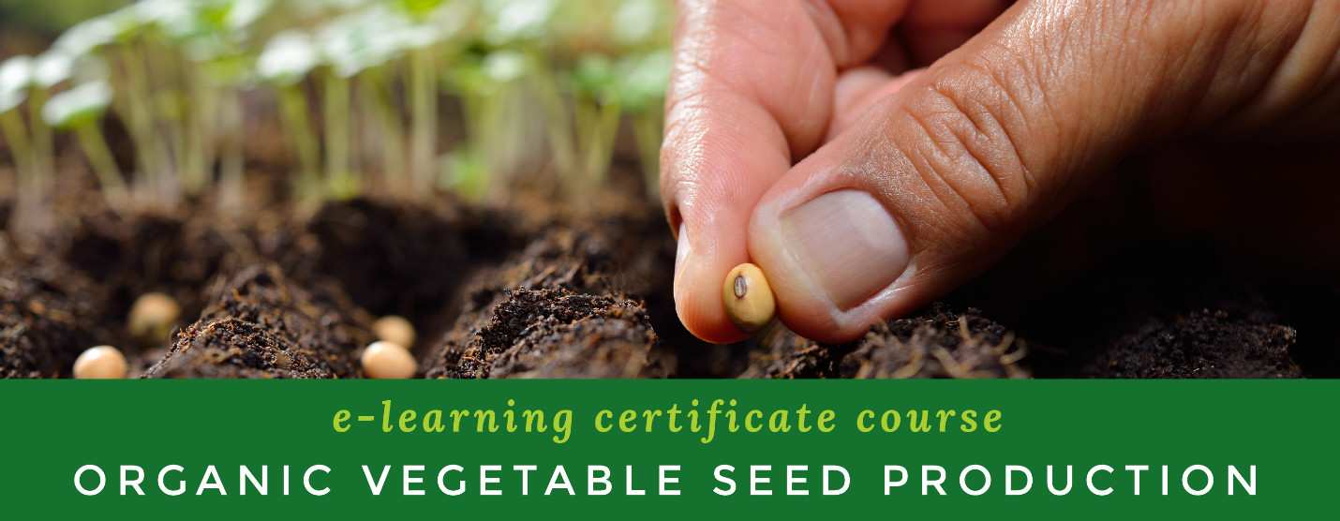
TWITTER: Please post with image above.

Want to learn more about producing organic seeds? @CanadianOrganic is launching a new intermediate online course: cog.ca

SEEDS SEEDS SEEDS! Want to learn more about Organic Vegetable Seed Production? @CanadianOrganic e-certificate: http://www.cog.ca/

@CanadianOrganic is launching a new intermediate e-Certificate. It begins April 10th. Check it out: http://www.cog.ca/ #seeds #organic

Want to learn about organic vegetable seed production, harvesting, quality, marketing & breeding? http://www.cog.ca @CanadianOrganic

Ever wonder what it takes to be an organic vegetable seed producer? Learn w/ @CanadianOrganic's new e-certificate. http://www.cog.ca/

FB POSTS: Please post with image above.

@CanadianOrganic is launching Canada’s first e-Learning certificate course exploring the ins and outs of Organic Vegetable Seed Production. This certificate begins on April 10th and will run until November (with a summer break in July and August). Sign up before April 1st to take advantage of the early bird discounts (they’re worth it!).

More information here: http://www.cog.ca/our-services/seedproductioncourse/
-------

SEEDS! SEEDS! SEEDS!
Want to learn more about producing organic seeds? Want to learn more about their commercial production, harvesting, quality, marketing, breeding and more? Want to build your own seed business following your own unique seed-farm business plan? If so, check out our upcoming e-Learning certificate course, “Organic Vegetable Seed Production.”
Register before April 1st to take advantage of their early-bird discounts!
HYPERLINK "http://www.cog.ca/our-services/seedproductioncourse/"http://www.cog.ca/our-services/seedproductioncourse/
-------

